**Assignment 3: Infographic- Cover letter**

| **HBR paper title** | *Using Technology to Create a Better Customer Experience* |
| --- | --- |
| **Tutorial number** | *12* |
| **Group Member Participants** | **Student No.** |
| *Group leader:*  *Koda Sleiman* | *24981742* |
| *Peter Nguyen* | *24920579* |
| *Layan Barasheed* | *24973380* |
| *Zhitan Wu* | *24747735* |
| *Edison Zhou* | *24756278* |
| *Ricky (Arie) Oberholzer* | *24823332* |

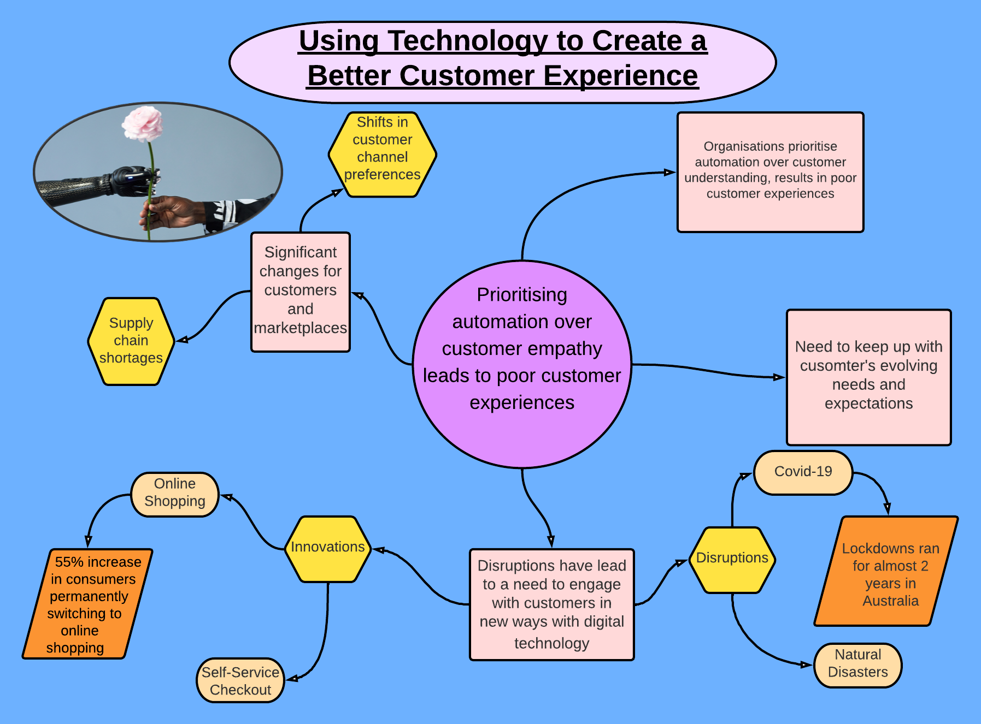

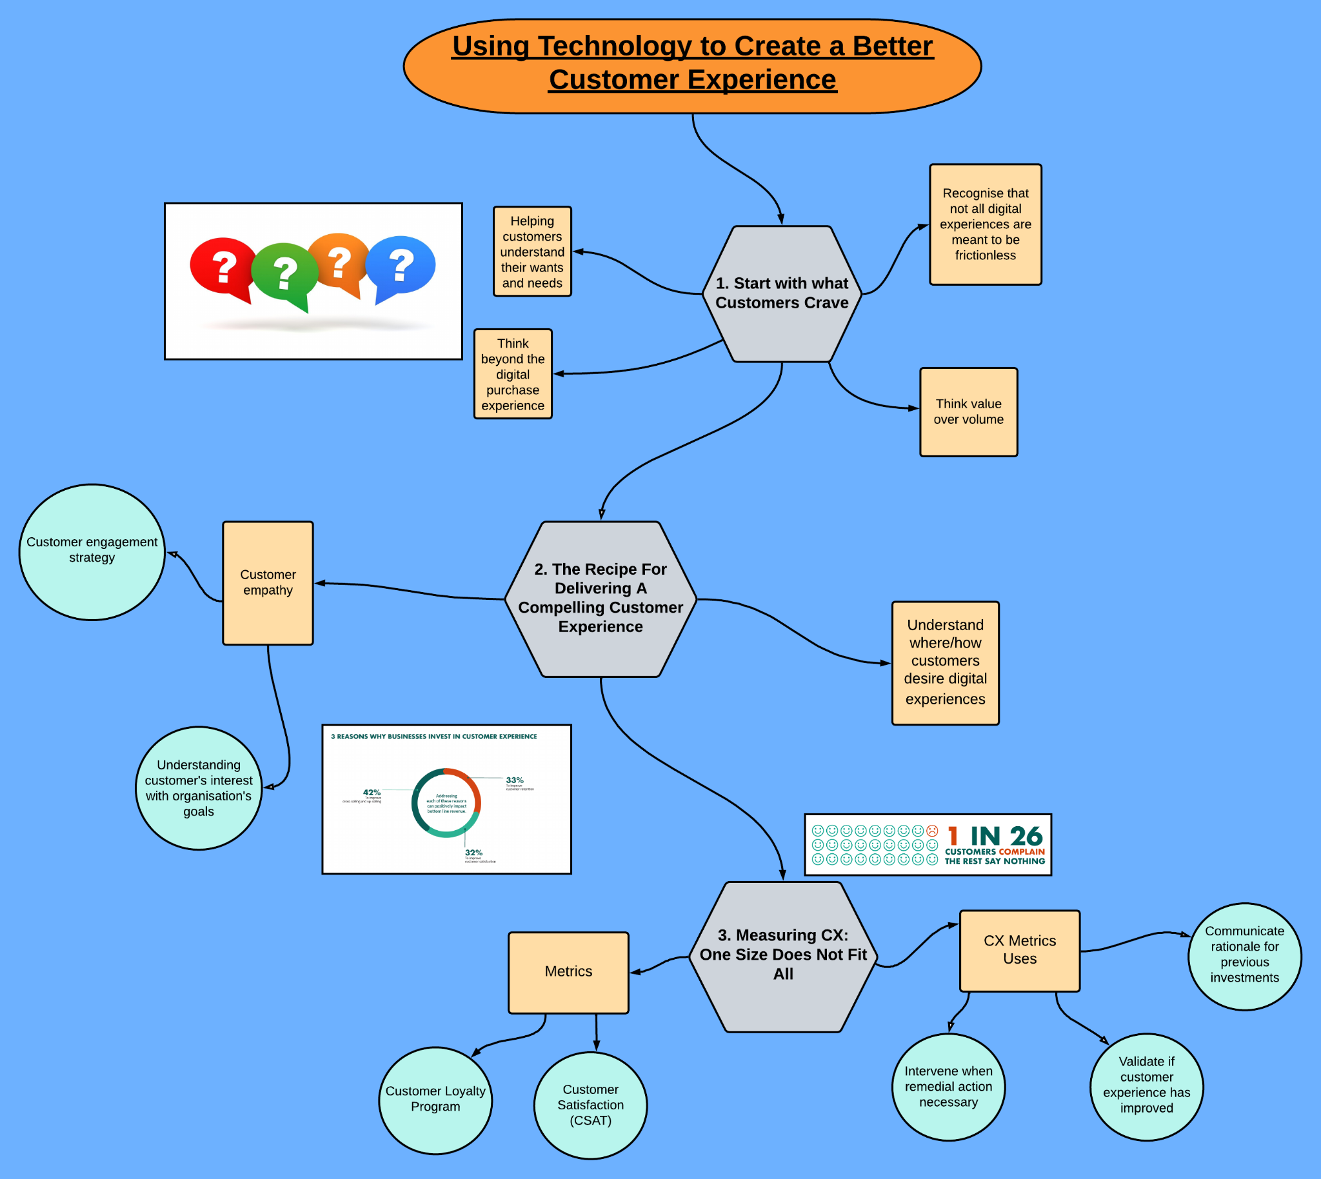

**Problem?**: Prioritising automation over customer empathy leads to poor customer experiences

* Significant changes for customers and marketplaces
  + Supply chain shortages
  + Shifts in customer channel preferences
* Need to keep up with customer’s evolving needs and expectations
* These disruptions have lead to a need to engage with customers in new ways with digital technology
  + Online shopping
  + Self-service
* Organisations prioritise automation over customer understanding, results in poor customer experiences

**Solution Process:**

**1. Start with What Customers Crave**

* General
  + Helping customers better understand their wants and needs will help in making them come back to the brand/product
  + “only 14% of customers had a digital interaction with a brand that led them to do something differently.”
  + Instead of advertising branding, companies should instead help customers better understand themselves
* Recognise that not all digital experiences are meant to be frictionless
  + Friction in a better experience can lead to customer self-reflection
  + Self-reflection deepens their understanding of how to achieve goals
* Think value over volume
  + Unique brand experience can have a lasting personal impact
  + Can change a customer’s viewpoint and behaviour
* Think beyond the digital purchase experience
  + Showing the value of the product or service once owned increases likelihood customer will stay and buy more

**2. The Recipe For Delivering A Compelling Customer Experience**

* Cultivate customer understanding
  + Understand where and how customers desire digital experiences
    - Voice of the customer (VoC)
    - Defining personas
    - Developing customer journey maps
    - Inspiring more customer-centric decisions
  + Customer empathy
    - Element of customer engagement strategy
    - Balance understanding customer’s situation, interest and intent with organisation’s goals

Compelling customer experiences don’t have to involve over-the-top digital

capabilities. Small things grounded in human understanding can be just as powerful.

* Take a holistic approach with total experience
  + Employee experience just as important as customer experience, impacts on customer experience
  + Total experience (Employee, Customer and User experience) with the goal of better shared experiences for all stakeholders
  + Consider the needs of customers and employees first, technology second
* Avoid “Engineered Insincerity”
  + Balance customer empathy with technology
  + Don’t use automation to simulate interest with no sense of understanding customer situation and desires

**3. Measuring CX: One Size Does Not Fit All**

* Customer experience metrics have several uses
  + Communicate rationale for previous investments
  + Validate if customer experience has improved
  + Set goals and targets for future improvement
  + Intervene when remedial action necessary
* Organisations will use variety of CX Metrics that align with key roles across marketing, IT, customer service and product development
* Metrics
  + Customer Satisfaction (CSAT)
    - Oldest and most widely used metric
  + Customer Loyalty Program participation or retention
    - Key indicator of the value customers see from engaging with your company
  + The Net Promoter Score (NPS)
    - Widely used barometer of the state of the customer relationship
  + Employee Engagement
    - Recognises the role of employees in customer experience
  + The Customer Effort Score (CES)
    - More precise way to measure if you are truly easy to do business with